**Unit-V**

**Macroeconomic Indicators**

**Contents**

1. Prices and inflation , Consumer Price Index
2. Exchange rate
3. Gross Domestic Product (GDP)
4. Components of GDP
5. The Labour Market
6. Money and Banks
7. Interest rate
8. Macroeconomic Models
9. Numericals on GDP Calculations
10. ESG overview

**1. Prices and inflation**

### **1.1. Prices and Price Level**

### When we talk about prices in macroeconomics, we’re referring to the monetary value assigned to goods and services across the economy, which reflect the interaction between supply and demand. These prices act as signals to guide resource allocation—whether we need to produce more wheat or less electronics, for example. When the price of crude oil rises, it might indicate a shift towards alternatives or a reduction in consumption. The price level, then, aggregates these individual prices into an overall average, representing the general cost of goods and services in the economy and providing a snapshot of purchasing power and inflation.

We measure the price level using tools like the Consumer Price Index (CPI) or the GDP Deflator. These indices track changes in the cost of a standard basket of goods and services over time. For example, if the CPI increases from 250 to 275 over a year, that’s a 10% rise in the price level, signaling inflation.

### **1.2. Price Level and Time**

The price level is not constant; it changes over time depending on economic conditions. Historically, during the Great Depression (1929–1939), we saw a sharp decline in the price level due to a collapse in demand. In contrast, during the 1970s oil crises, the price level surged due to cost-push inflation as oil shortages led to higher production costs across the economy. The U.S. inflation rate peaked at 13.5% in 1980 during that period.

More recently, the COVID-19 pandemic caused significant disruptions to global supply chains, leading to both demand and supply shocks. As economies recovered in 2021–2022, expansive monetary and fiscal policies were implemented—such as stimulus packages and low-interest rates—which drove a sharp increase in the price level. For instance, the U.S. CPI rose by 6.8% in 2021, the fastest rate since 1982.

Technology also influences price levels over time. For instance, the cost of electronics has generally decreased due to efficiency improvements and economies of scale, even as the broader price level has increased. This highlights that while the aggregate price level may rise, individual sectors can behave quite differently.

### **Mathematical Perspective**

To understand the relationship between the price level and time, we often refer to the Quantity Theory of Money, which states:

MV=PY

Here:

* M is the money supply.
* V is the velocity of money(rate at which money circulates through the economy from one transaction to the next).
* P is the price level.
* Y is real output.

When the money supply grows faster than real output, the price level tends to rise. For example, if an economy’s money supply increases by 15% but real output grows by only 5%, the price level should rise by about 10%.

Looking at history, this theory is evident. In Zimbabwe (2007–2008), hyperinflation occurred when the government printed excessive money to cover expenditures, causing the price level to double approximately every day at its peak.

Understanding how price levels change over time helps us analyze inflation, deflation, and growth, which are essential for shaping economic policies aimed at stabilizing the economy and promoting sustainable development.

**1.3. Price index**

A price index is a statistical measure that tracks changes in the average price level of a fixed basket of goods and services over time. It is used to assess inflation or deflation trends and understand how the overall price level evolves. The primary goal of a price index is to express these changes as relative percentages, making it easier to compare price movements across different periods.

To calculate a price index, each price level is normalized relative to a base value, typically set to 100. This normalization helps simplify comparisons by expressing price changes in percentage terms. For instance, if January 1, 2008 is selected as the base period with an index of 100, this acts as a reference point. From January to February, the index rises to 102.68, indicating a 2.68% increase in prices. This trend continues with the index climbing to 103.42 from January to March, reflecting a 3.42% rise in prices over the three-month period. The percentage change calculation remains consistent regardless of which point is used as the base, showing that the trend in price changes is stable over time.

For example, in a period of rapid economic change, such as the 1970s when oil prices surged, a price index like the CPI (Consumer Price Index) would show a sharp increase, reflecting cost-push inflation driven by higher energy costs. Similarly, during the Great Recession, when consumer spending dropped significantly, the index might show slower growth, indicating deflationary pressures. The consistency of percentage change calculations in price indices allows economists to track these trends and adjust monetary and fiscal policies accordingly. This is crucial for understanding how changes in the price level impact purchasing power and guide decisions on interest rates, taxes, and government spending aimed at managing inflation and deflation.

**1.4 Consumer Price Index (CPI)**

The Consumer Price Index (CPI) is a widely used economic indicator that measures changes in the price level of a fixed basket of goods and services purchased by households over time. It provides a snapshot of the cost of living and is a key tool for assessing inflation. The CPI reflects changes in consumer prices and is used to adjust income payments, wages, and pensions to maintain purchasing power. It helps policymakers and economists gauge the cost of living, compare inflation rates, and make informed decisions about monetary and fiscal policies.

To calculate the CPI, a representative basket of goods and services—such as food, clothing, housing, medical care, transportation, and entertainment—is selected. Each item in the basket has a specific weight based on its expenditure share in the average household budget. These items are then priced at regular intervals to monitor price changes over time. The CPI is calculated using a Laspeyres formula, which compares the total cost of the basket in the current period to the cost in the base period, multiplied by 100. For example, if the total cost of the basket in the base period (say January 2008) is $600, and in the current period (say February 2008) it is $616, the CPI would be:

CPI = = = 102.67

This indicates a 2.67% increase in the cost of living from January to February, showing a moderate rate of inflation. The CPI helps in adjusting wages and social security payments to reflect changes in the cost of living, ensuring that income retains its purchasing power. It also plays a crucial role in economic policy by influencing decisions related to interest rates, taxation, and government spending aimed at managing inflation and supporting economic stability.

Figure 1 presents the Consumer Price Index (CPI) for Germany following reunification, starting from January 1991. The reference year for this data is 2005, indicating that the CPI is normalized to 100, on average, for that year.

**Figure 1.1:**

**Consumer price Index (CPI) for Germany 1991-2010. Source: OECD**

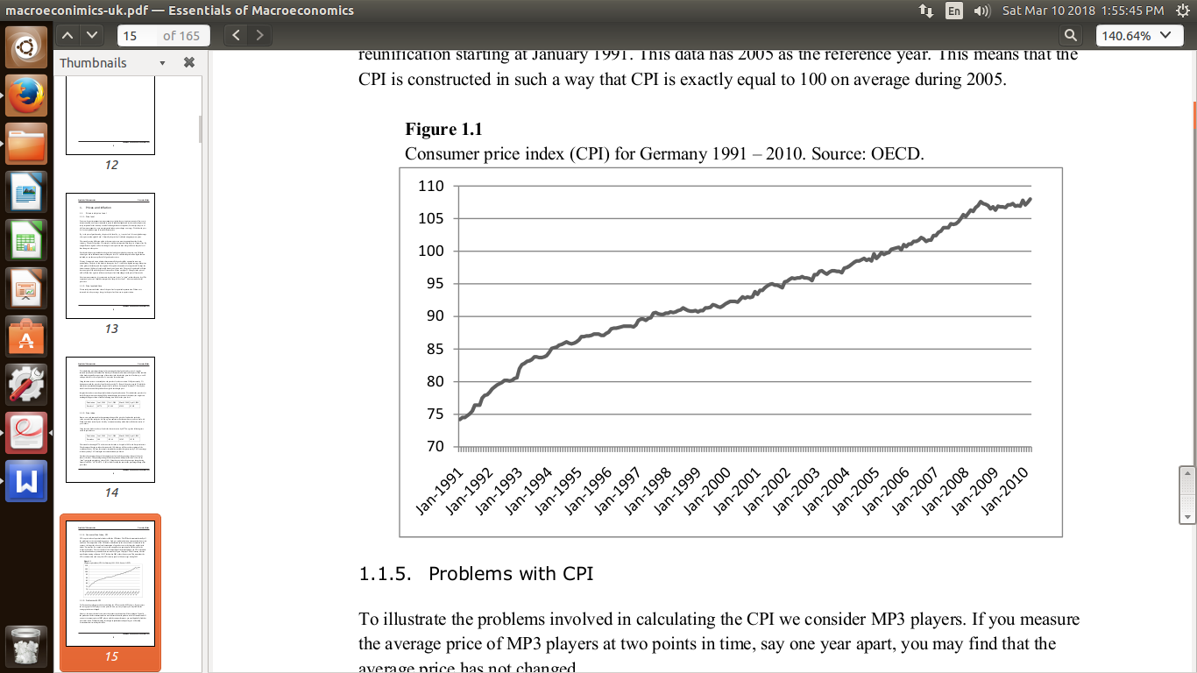

**1.5 Problems with CPI**

For instance, imagine a small town with a diverse population of tech-savvy consumers. If we measure the price of a popular brand of smartphones at two different points in time—say one year apart—we might find that the average price hasn’t changed much. However, this isn’t the full picture. Over the year, the market has shifted from offering basic smartphones to models equipped with advanced features like high-resolution cameras and larger screens. If we compare prices of phones with similar performance, we would likely find that the real price has actually fallen. Failing to adjust for these improvements in performance can lead to an overestimate of the CPI’s inflation rate, giving a skewed picture of the true cost of living.

**1.6 Inflation**

The inflation between two points in time is defined as the percentage increase of the price index between these two points in time.It is typically measured as an annual percentage change in a price index, such as the Consumer Price Index (CPI). Inflation reflects a decline in purchasing power of a currency, meaning that each unit of currency buys fewer goods and services than before. Moderate inflation can be beneficial for an economy, encouraging spending and investment, but high inflation can erode consumer confidence and disrupt economic stability.

For example, consider a small agricultural town where the primary economic activity revolves around farming and local markets. In the previous year, the town experienced moderate inflation due to a bad harvest that pushed up the prices of staple foods like bread and vegetables. The CPI, which measures the average price of these items, showed a 5% increase over the year. This inflation affected the residents’ daily lives significantly as their purchasing power diminished, and the cost of living increased. Farmers and small business owners had to adjust prices more frequently, and families had to cut back on non-essential spending. The local government responded by implementing subsidies to support low-income households and control inflation, which highlighted the challenges of balancing growth and stability in a changing economy.

**2. Exchange rate**

**2.1. Definition**

The exchange rate represents the price of one currency in terms of another and is central to understanding international trade and economic interactions. For example, if 1 euro costs 1.5 USD, then 1 USD would cost = 0.667 euros. The currency being quoted first (euro in this case) is called the base currency, while the other (USD) is the quote currency. Exchange rates can be expressed using two methods: the direct method, where the foreign currency is the base (e.g., 1 USD = 4.8 Danish Kronor in Denmark), and the indirect method, where the home currency is the base (e.g., 1 GBP = 9.2 Danish Kronor in the UK). Understanding the notation is essential for interpreting how much one currency can buy of another.

Countries adopt different exchange rate systems to manage the value of their currencies. In a flexible exchange rate system, market forces of supply and demand determine the rate. For example, after the collapse of the Bretton Woods system in the 1970s, the US dollar moved to a flexible exchange rate. In contrast, a fixed exchange rate pegs the currency to another, such as Hong Kong’s fixed rate of 7.8 HKD/USD. There is also the managed float system, where central banks intervene occasionally to influence exchange rates. Lastly, countries in a monetary union, such as the European Union with its shared euro, have no internal exchange rates but must decide their collective stance against external currencies.

**2.2. Changes in Exchange Rates**

When the value of one currency changes relative to another, we talk about appreciation and depreciation. For instance, if the euro costs 1.5 USD today and rises to 1.6 USD tomorrow, the USD has depreciated (lost value) relative to the euro, while the euro has appreciated. Depreciation can make imports more expensive but boosts exports by making them more competitive internationally. Conversely, appreciation makes imports cheaper but can hurt export competitiveness.

To illustrate, consider Japan tracking the competitiveness of its yen. If Japan’s yen depreciates by 10% against a basket of currencies (measured via the effective exchange rate, which weights multiple currencies), Japanese goods become cheaper globally, potentially boosting exports. However, it might also lead to higher domestic prices for imported goods, contributing to inflation. Such fluctuations demonstrate the dual-edged nature of exchange rate changes and their profound impact on economies.

**2.3. Exchange rate systems**

An exchange rate system determines how a country manages its currency value relative to others. The main types are:

**a. Flexible Exchange Rate System**

In a flexible system, market forces of supply and demand determine the exchange rate without government intervention. For example, the US dollar operates under this system. It provides adaptability but can cause volatility, especially for economies reliant on imports or external debt.

**b. Fixed Exchange Rate System**

A fixed system pegs a country’s currency to another currency or a basket of currencies. For instance, the Hong Kong dollar is pegged to the US dollar at 7.8 HKD/USD. This system offers stability for trade and investment but demands significant foreign reserves to maintain the peg and limits responses to economic shocks.

**c. Managed Float System**

This "hybrid" system allows exchange rates to fluctuate but involves central bank intervention to prevent extreme volatility. For example, India operates under a managed float, where the Reserve Bank of India steps in during excessive fluctuations. It balances flexibility with some control.

**d. Monetary Union**

A monetary union involves multiple countries adopting a single currency, such as the euro in the EU. There are no internal exchange rates, but the shared currency’s value fluctuates against others. This system requires coordinated fiscal and monetary policies but eliminates exchange rate risk within the union.

Historically, systems like the gold standard and the Bretton Woods system provided fixed exchange rate frameworks but were eventually replaced by more flexible systems due to their limitations in addressing global economic changes.

**2.4. Changes in the exchange rate**

Changes in the exchange rate are a fundamental aspect of international economics, influencing trade balances, inflation, and capital flows. Let’s consider a hypothetical case study for India to explore these dynamics.





Imagine the exchange rate between the Indian Rupee (INR) and the US Dollar (USD) is initially 75 INR/USD. Over time, increased foreign investments in India and robust economic growth lead to the rupee appreciating to 70 INR/USD. In this scenario, the rupee has strengthened relative to the dollar. This appreciation means that imports, such as crude oil or electronic goods, become cheaper for Indian consumers. For example, if India imports oil priced at $100 per barrel, the cost in rupees falls from ₹7,500 (at 75 INR/USD) to ₹7,000 (at 70 INR/USD). This can help reduce inflationary pressures in the economy. However, exporters face challenges as their goods and services become relatively more expensive for international buyers, potentially reducing demand.

Now consider the reverse scenario, where the rupee depreciates to 80 INR/USD, perhaps due to geopolitical tensions or capital outflows. In this case, Indian exporters benefit as their products become more competitive globally—for instance, a software service priced at $1,000 now fetches ₹80,000 instead of ₹75,000. However, the cost of imports rises, such as oil now costing ₹8,000 per barrel instead of ₹7,500. This depreciation can lead to higher domestic inflation as the prices of imported goods and raw materials increase, impacting production costs and the cost of living.

These examples illustrate how exchange rate changes, whether through appreciation or depreciation, have cascading effects across an economy. Additionally, in a fixed exchange rate system, governments or central banks may actively adjust the rate. For instance, if the Reserve Bank of India (RBI) were to peg the rupee at 75 INR/USD and then adjust it to 80 INR/USD, this would be termed a devaluation, making the dollar more expensive. Conversely, changing it to 70 INR/USD would constitute a revaluation, strengthening the rupee against the dollar.

**2.5. Effective exchange rate**

The effective exchange rate is a key indicator for assessing a country’s external competitiveness. It reflects the value of a currency relative to a basket of other major currencies rather than just one. This method helps isolate the currency’s strength or weakness from specific bilateral exchanges, offering a broader view of economic performance.

For instance, if we want to evaluate India’s external competitiveness, we consider the exchange rate between the Indian Rupee (INR) and the US Dollar (USD), but also include other currencies like the Euro and the Chinese Yuan. The direct exchange rate might be influenced by factors not directly related to India, so we turn to the effective exchange rate for a clearer picture.

To calculate the effective exchange rate, we take a weighted average of the exchange rates of these currencies. The weights reflect the importance of trade flows with each currency’s country. For instance, if the Euro (EUR) accounts for 40%, the Chinese Yuan (CNY) 30%, and the US Dollar (USD) 30% of trade, we calculate the effective exchange rate as:

Effective Exchange Rate=(0.4×90)+(0.3×11)+(0.3×75)

Effective Exchange Rate=(36+3.3+22.5)=61.8 INR/USD

An increase in the effective exchange rate indicates that the Rupee has appreciated, making Indian exports more expensive globally. A decrease suggests depreciation, making Indian goods cheaper and boosting export competitiveness. For example, if the effective exchange rate drops from 61.8 INR/USD to 55 INR/USD, it reflects depreciation, enhancing demand for Indian goods abroad.

**3. Gross Domestic Product (GDP)**

**3.1. Definition**  
 Gross Domestic Product (GDP) is a fundamental economic indicator that measures the total market value of all final goods and services produced within a country over a specific time period, typically a year or a quarter. It serves as a comprehensive measure of economic activity and output. The definition of GDP is inclusive of all goods and services sold directly to consumers to avoid double counting. For example, if a car manufacturer buys tires from a supplier, the value of those tires is not included in GDP calculations; only the final sale price of the car counts.

**3.2. Real GDP**  
 Real GDP adjusts nominal GDP for inflation to provide a clearer picture of economic growth. It measures the actual increase in production and income by dividing GDP by a price index, typically a GDP deflator. This adjustment is essential for comparing economic performance over time or across different economies. For example, if prices double over a year, nominal GDP would also double, but real GDP growth would reveal that the economy’s output actually grew at a slower pace. The GDP deflator is preferred over CPI for these calculations because it measures the price evolution of a broader set of goods and services included in GDP.

**3.3 Growth**  
 Economic growth refers to the percentage change in GDP over a specific period. Real GDP growth excludes the effects of inflation, providing a more accurate measure of how much the economy has grown. It reflects genuine increases in production and income rather than price changes. For instance, if real GDP grows by 3% over a year, it indicates that the economy has expanded by that percentage after adjusting for inflation. This metric is crucial for understanding the health of an economy and guiding policy decisions.

**3.4. Purchasing Power**  
Purchasing power adjusts for differences in price levels across countries, allowing for a more accurate comparison of GDP per capita. Exchange rates can be volatile and may not always reflect the true economic standing of a country. By using purchasing power, economists can compare the cost of living and the standard of living more effectively. For instance, when comparing GDP per capita between the United States and India, using purchasing power parity (PPP) rather than nominal exchange rates helps account for the lower cost of living in India, providing a more realistic picture of economic well-being.

**3.5. GDP as a Flow**GDP is a flow variable, measuring economic activity over a specific time period rather than a stock variable, which measures a quantity at a point in time. It tracks the flow of income, spending, and production within an economy, similar to how we measure water filling a bath in liters per minute (flow) rather than the total volume in the tub (stock). This distinction is important because it indicates that GDP reflects the current economic activity and not accumulated wealth. High GDP often correlates with wealth creation over time, but it doesn’t account for depreciation or changes in the stock of capital.

**4. The components of GDP**

**4.1. The Circular Flow – Simple Version** Gross Domestic Product (GDP) is defined as the market value of all finished goods and services produced within a country during a specific period of time. To better understand GDP, we utilize the “circular flow model”, which shows how goods, services, and money circulate between various sectors of the economy. In this model, goods (and services) flow counterclockwise while money flows clockwise. Firms deliver finished goods to the goods market, and they are compensated for these goods, which equals GDP. Consumers receive these goods from the goods market and pay for them by providing factors of production (labor and capital) to the factor markets. Firms purchase these factors using the income they receive from the goods market.

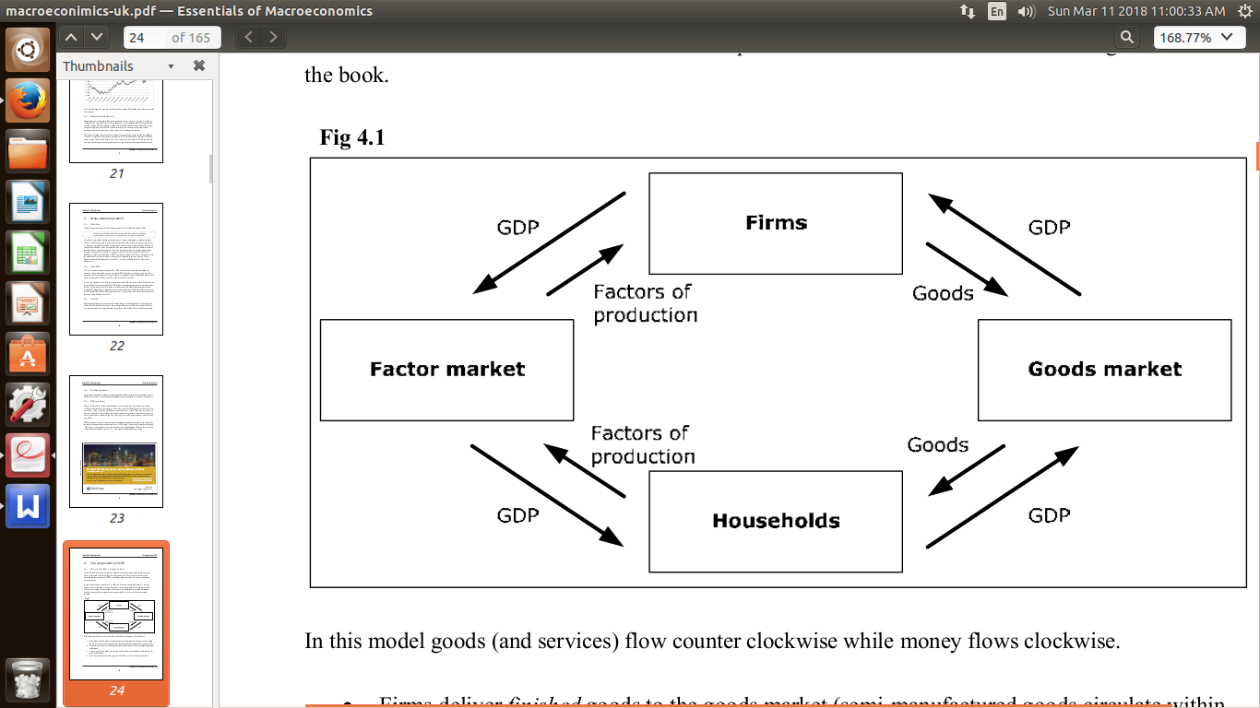

**4.2. Modeling a Firm and the Concept of Value Added** A firm in this model adds value to products as they progress through the production process. This value addition is defined as the difference between revenue and the cost of goods. For example, a supermarket buys fish for €4 and sells it for €5, adding €1 in value. This process ensures that only the final value added at each stage is counted, preventing double counting in GDP calculations. The total value added from all firms is equal to the compensation to the factors of production (wages, rent, profit), reflecting the net flow of money through firms.

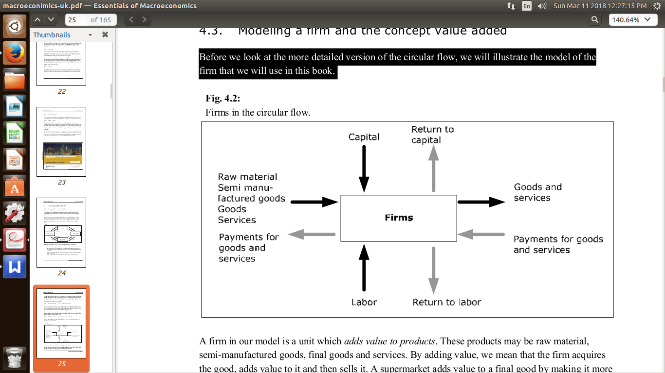

Consider a small bakery. The bakery starts by purchasing flour, yeast, water, and other ingredients. The total cost here represents the raw material value added. The ingredients are then mixed to make dough, which is allowed to rise and be shaped into loaves. The value added at this stage includes the costs of labor (bakers), rent for the bakery space, and other operational costs. Finally, completed loaves are baked, packaged, and sold to consumers. The value added here represents the final product's sale price minus the cost of inputs. This way, GDP includes only the value added at each stage, avoiding any overstatement of economic output.

Alternatively, consider an electronics assembly plant that assembles smartphones. The plant sources various components like microchips, batteries, screens, and casing parts. The value added at this stage covers the purchase price minus any discounts or rebates. Components are then assembled into printed circuit boards (PCBs) and partially completed smartphones. The value added includes labor costs for assembly workers, rent for the factory, and profit margins. Finally, completed smartphones are tested, packed, and sold. The value added here represents the final sale price minus the costs of raw materials and semi-manufactured goods. This interconnected process helps in accurately measuring economic output without duplication, ensuring that GDP reflects genuine economic activity.

**4.3. Firms in the Circular Flow** Firms are divided into three categories: FR (firms acquiring raw materials), FH (firms producing semi-manufactured goods), and FF (firms producing finished goods). GDP, denoted as Y, will flow from FR to FH and then to FF. The value added for each firm category must sum up to GDP:

* **YR** is the total value of all goods going from FR to FH.
* **YH** is the total value added by firms in the FH category.
* **Y – YH** is the total value added by firms in the FF category (finished goods producers).This distribution ensures that the total return to factors of production (wages, rent, and profit) matches the sum of all value added in the economy.

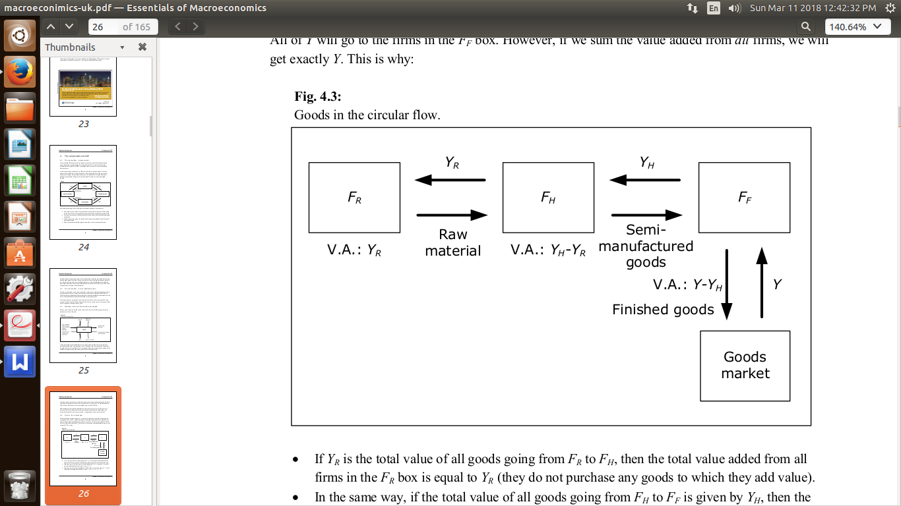

For instance, consider a small electronics manufacturing firm that assembles smartphones. This firm purchases raw materials like metal, glass, and microchips from suppliers, and hires labor to assemble these components. The costs of these inputs – including wages paid to assembly line workers, rent for the factory space, and payments for utilities – represent the firm's value added.

Assuming the firm spends $100,000 on raw materials, $50,000 on wages, and $30,000 on rent and utilities, the total value added by the firm is $180,000. This value is part of the GDP, reflecting the economic contribution of the manufacturing sector. After producing smartphones, the firm sells them to retail stores and online platforms, earning revenue from these sales. The money spent by consumers on these smartphones circulates back into the economy, allowing the firm to pay its suppliers, employees, and taxes, thereby continuing the flow of income and production in the circular flow model.

This example illustrates how firms are interconnected with other sectors of the economy, with their activities driving GDP growth and economic stability.

**4.4. Circular Flow – Circulation of Goods** In a more developed version of the circular flow, we include additional sectors such as the Government and the Rest of the World. Finished goods in the goods market are divided into categories: private consumption (households), public consumption (government services), investment (firms), and exports (to other countries). Imports from the rest of the world also enter this model, showing how goods flow through different sectors of the economy. This expanded view helps understand the complete economic activities beyond just domestic production.

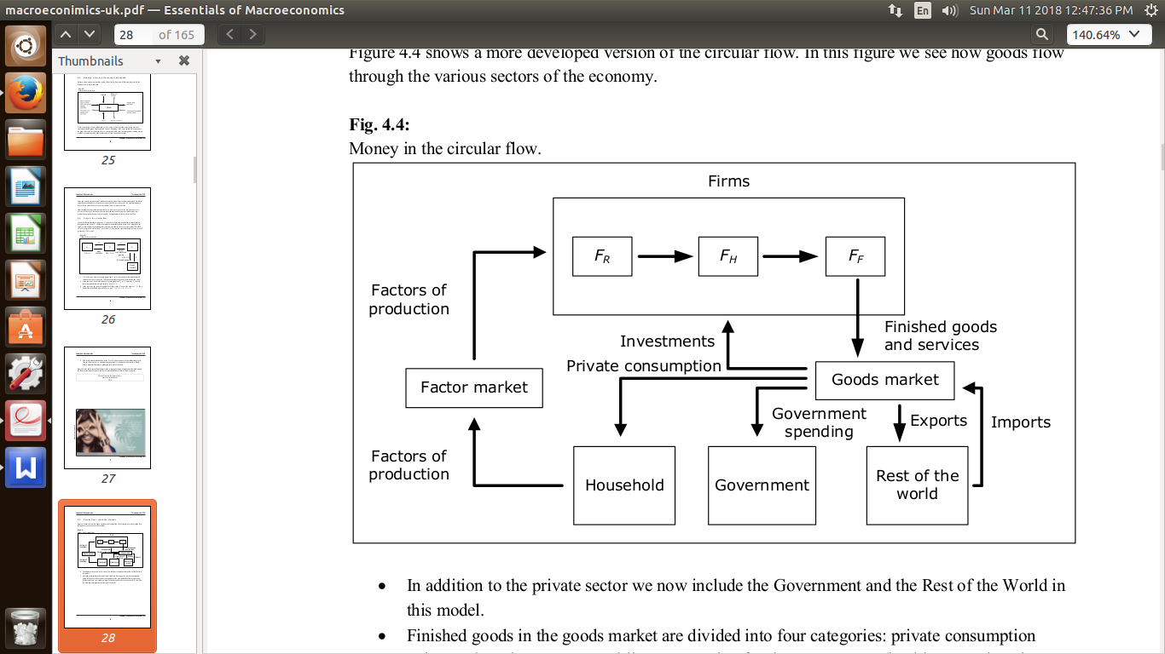

In a small town economy focused on bicycle manufacturing:

1. **Private Consumption**: Households purchase bicycles from local firms. If 500 bicycles are sold at an average price of $300 each, private consumption is $150,000. This spending injects money back into the local economy.
2. **Public Consumption**: The government buys bicycles for public services, such as police departments or community centers. If it purchases 50 bikes at $300 each, public consumption is $15,000. This spending also circulates back into the economy.
3. **Investment**: Local firms reinvest profits into expanding production capacity. Suppose a bicycle manufacturer invests $100,000 in new machinery and equipment, boosting local production and employment.
4. **Exports and Imports**: Some bicycles are exported, generating revenue. If the town exports 100 bikes at $350 each, exports total $35,000. Imports, like 50 bikes at $250 each, cost $12,500. These trade activities affect the circular flow by bringing in foreign revenue and increasing the demand for imports.
5. **Total Circular Flow of Goods**: Summing up all transactions, the total value of goods circulating in the economy is:

Total Circular Flow = Private Consumption+ Public Consumption+ Investment+ Exports- Import

Total Circular Flow=150,000+15,000+100,000+35,000−12,500=287,500

This model highlights the interconnectedness of sectors in the economy, showing how each contributes to GDP and overall economic activity.

**4.5. Circular Flow – Circulation of Money** Money circulates in the circular flow as firms pay wages, rent, and profits to households, who then use this income to purchase goods and services. This flow represents the transfer of purchasing power in the economy. When money circulates smoothly, it supports economic stability and growth. The relationship between the circulation of money and goods highlights the interconnectedness of income, spending, and production within an economy.

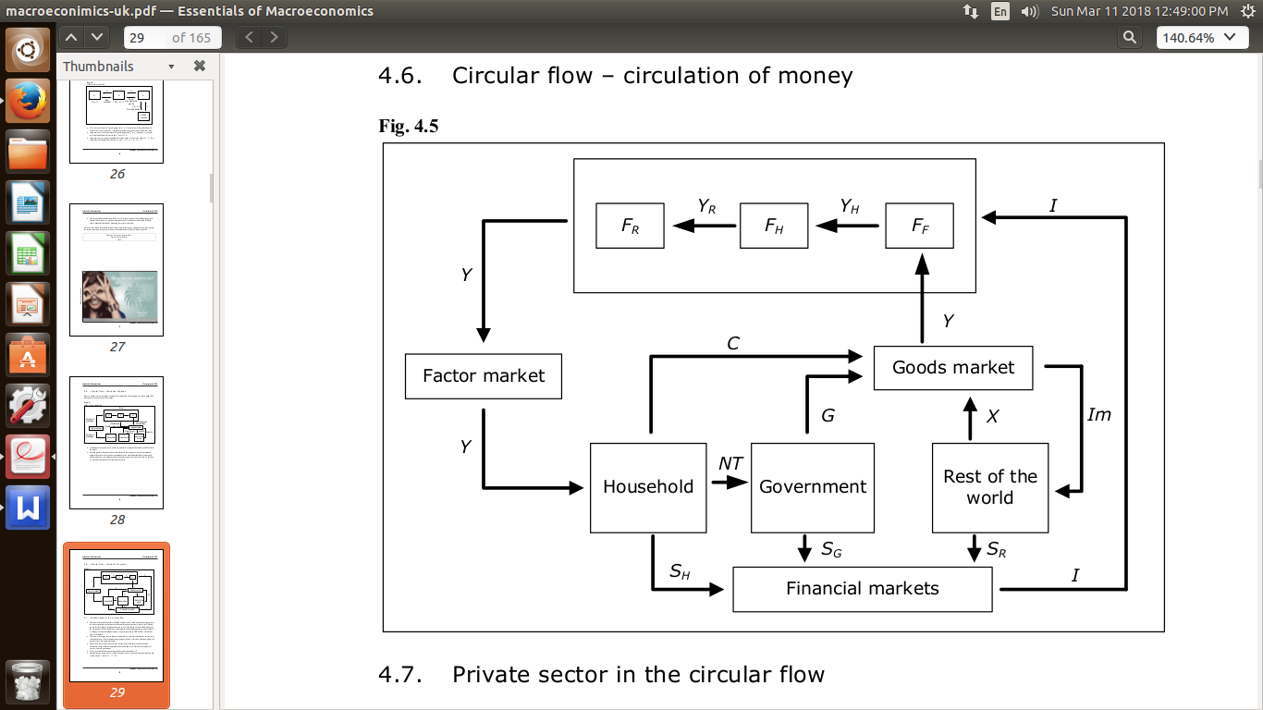

In a local economy centered around a small manufacturing town, the circular flow of money tracks how income is generated, spent, and redistributed among different economic actors.

1. **Households**: Households earn income through wages, rent, and profits from the firms they work for. If the average monthly income per household is $2,000, and there are 1,000 households, total household income is $2,000,000 per month.
2. **Firms**: Firms use this income to purchase factors of production like labor and raw materials. If the total spending by firms on wages and inputs is $1,200,000, this spending becomes income for other households and firms in the circular flow.
3. **Government**: The government collects taxes on income, business profits, and transactions. If the government collects $300,000 in taxes, it uses these funds for public services such as infrastructure, education, and law enforcement.
4. **Rest of the World**: The town exports goods, such as bicycles, to other countries, bringing in $150,000 per month. However, imports of raw materials and consumer goods cost $100,000 per month. This trade balance injects foreign currency into the local economy and adjusts the money supply.
5. **Total Circular Flow of Money**: Summing all these transactions, the total flow of money in the local economy is:

Total Circular Flow of Money = Household Income+Firm Expenditures+Government Revenue+

Net Exports

Total Circular Flow of Money = 2,000,000+1,200,000+300,000+(150,000−100,000)=3,550,000

This model helps to understand how money circulates through an economy, showing how income and expenditures are interconnected and illustrating the balance between local production, consumption, and trade.

**4.6. Private Sector in the Circular Flow** The private sector's total income, often referred to as national income, is essentially equal to the GDP. This is represented by the symbol Y. While GDP measures the total market value of all finished goods and services produced within a country, national income reflects the earnings of households and firms from all sources.

The private sector contributes to national income through wages, rents, and profits. Taxes are a significant part of this income, including income taxes, value-added taxes, selective purchase taxes, and payroll taxes. For instance, if there are 1,000 firms and each pays an average of $10,000 in taxes per month, total tax revenue could be $10,000,000. These taxes contribute to government revenue, which is then used to fund public services and transfers such as pensions, unemployment benefits, and child allowances.

Net tax revenue (NT) is calculated as total taxes minus transfers. Using a simple example, if total taxes amount to $12 million per month and transfers to households total $4 million per month, net tax revenue would be $8 million.

Disposable income (YDisp) is the income remaining after taxes and transfers, calculated as

YDisp = Y - NT. If national income is $20 million and net tax revenue is $8 million, disposable income would be $12 million. Households and firms use this disposable income for consumption (C). If consumption (C) exceeds disposable income (YDisp ), it indicates that the private sector is borrowing money. For example, if consumption is $15 million and disposable income is $12 million, savings (SH) would be negative ($3 million), showing that the private sector is in deficit, indicating borrowing to finance additional consumption or investment.

This relationship is crucial for understanding how income, taxes, savings, and borrowing balance within the private sector and impact overall economic stability and growth.

**4.7. Components of GDP**

Gross Domestic Product (GDP) represents the total market value of all finished goods and services produced within a country during a specific time period. To understand its composition, we break it down using the following accounting identities:

1. **Total Output Identity**: By considering all arrows to and from the goods market, we have:  
    Y+Im=C+I+G+X

Here, YYY represents total output or GDP, ImImIm is imports, CCC is consumption, III is investment, GGG is government spending, and XXX is exports. The left-hand side (Y+ImY + ImY+Im) is the value of all finished goods flowing into the goods market, while the right-hand side decomposes all goods into these four categories.

1. **Net Exports**: Moving Im to the right-hand side, we have:  
    Y=C+I+G+X−Im

Net exports (NX) are defined as X−Im, and they represent the amount that the rest of the world borrows from our country. Thus:  
 Nx= −SR

Where SR  stands for savings and net borrowing. The equation shows that net exports equal the difference between what is exported and what is imported.

1. **Components of GDP**: Combining these identities, we get:  
    Y=C+I+G+NX

Here, C, I, G, and NX are called the components of GDP. They represent private consumption, investment, government spending, and net exports, respectively.

1. **Accounting Identity from the Financial Markets**: Using SH=YDisp−C , SG=NT−G , and SR=Im−X, we have:  
    Y−NT−C+NT−G+Im−X=I

This equation shows that the national income minus net taxes and consumption (personal disposable income) equals the total investment III.

These accounting identities from both the goods market and the financial markets must hold true. They are interdependent: if one holds, the other must as well. The key takeaway is that GDP, expressed as Y, is the sum of consumption, investment, government spending, and net exports.



**4.8. Four different measures of GDP**

Using the circular flow model, we see that there are four equivalent ways of measuring GDP:

1. **Expenditure (or Spending) Method**: This method measures GDP by summing all expenditures on finished goods and services in the economy. It considers consumption (private and government), investment, and net exports (exports minus imports). The formula is:  
    Y=C+I+G+X−Im  
   Here, C represents consumption, I investment, G government spending, X exports, and Im imports. This approach highlights total economic demand and spending within a country.
2. **Value Added Method**: This approach calculates GDP by summing the value added at each stage of production. It avoids double-counting by considering only the value added at each step. The formula is:  
    Y=∑(Output−Intermediate Inputs)

This method provides a clearer view of the economic contribution of each sector without counting the same goods multiple times.

1. **Components (or Summation) Method**: Here, GDP is expressed as the sum of private consumption, government spending, investment, and net exports. It decomposes GDP into its fundamental components:

Y=C+I+G+X−Im  
This approach helps in understanding the major spending categories that contribute to economic activity.

1. **Income (or Earnings) Method**: This method calculates GDP by summing all incomes earned in the production of goods and services within a country. It includes wages, rents, interest, and profits paid to the factors of production. The formula is:  
    Y=W+R+I+P

Where W represents wages, R represents rents, I represents interest, and P represents profits. This approach focuses on the distribution of income among the factors of production.

Each of these methods provides a unique perspective on economic performance and is used to cross-verify the consistency of GDP estimates. They are interconnected and essential for a comprehensive analysis of the economy.

**4.9. Capital**

By capital, we typically refer to manufactured goods that are used to produce other goods and services but are not consumed in the production process. This includes physical assets like machines, computers, factories, and infrastructure. To distinguish it from financial capital, which consists of assets like bank deposits, stocks, and bonds, we often refer to capital as fixed capital. Fixed capital can be divided into two main categories:

1. **Physical Capital:** This includes tangible assets such as machinery, equipment, buildings, and infrastructure that are used in the production process. Physical capital enhances productivity and allows for the production of goods and services.
2. **Human Capital:** This refers to the skills, knowledge, education, and experience embodied in individuals that enhance their ability to perform tasks and contribute to the economy. It is a crucial component of economic growth and development.
3. **Social Capital:** This includes networks, relationships, and institutions that facilitate cooperation and coordination among individuals and groups. It contributes to the efficient functioning of markets and communities.

Consider a factory investing in new machinery and offering training programs to its workforce. The machinery represents physical capital, enhancing the factory’s production capacity. The training programs improve the employees’ skills, contributing to human capital. Together, these investments in physical and human capital increase productivity, reduce costs, and enable the factory to compete more effectively in the market. This case highlights how both types of capital are essential for economic growth and development.

**4.10. Investment**

Investment in economics refers to the process of allocating resources to acquire new assets or improve existing ones to increase future productive capacity. It encompasses gross investment, which includes all finished goods produced but not consumed. This involves both gross fixed investment and changes in inventories.

Gross fixed investment refers to the purchase of new fixed assets such as machinery, buildings, or equipment that will be used in production. For example, if a construction company buys new machinery to improve efficiency, this constitutes gross fixed investment. It enhances the economy’s productive capacity by adding new capital assets.

Changes in inventories occur when there are fluctuations between production and consumption. An increase in inventory indicates that production has outpaced sales, which counts as positive investment. Conversely, a decrease suggests that demand has exceeded production, signaling a negative investment. These inventory changes reflect businesses' responses to market dynamics and their strategies to manage stock levels.

Net investment, on the other hand, is calculated by subtracting depreciation from gross investment. Depreciation measures the reduction in value of capital assets over time due to wear and tear. Net investment represents the real increase in capital stock in an economy, indicating genuine additions to productive capacity over a specific period. This distinction is crucial because while capital is a stock variable (measured at a particular point in time), investment is a flow (measured over a period).

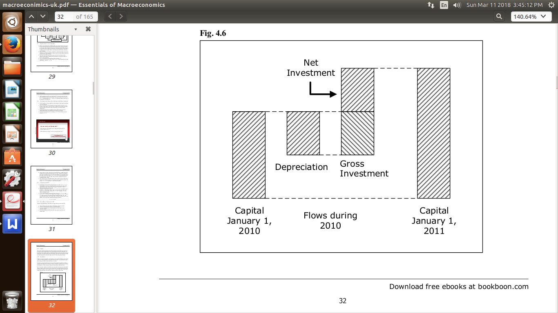

**5. The Labor Market**

**5.1. Introduction**

An important macroeconomic variable is the total amount of labor that is used in a certain time period. The amount of labor and the amount of capital are important explanatory variables for total production and GDP. Another reason for the importance of the amount of labor is that it is related to the unemployment rate – a macroeconomic variable which is clearly important.

**5.2. Unemployment classification**

Unemployment is a complex phenomenon with different types that can be distinguished based on their causes and the characteristics of those affected. Understanding these types is important for both economic analysis and policy-making. Here’s a deeper look at each category:

1. **Frictional Unemployment:**  Frictional unemployment occurs when individuals are temporarily out of work as they transition between jobs, enter the labor market for the first time, or exit after a job ends. This type is often short-term and always present in a market economy due to job searching, geographical relocation, or transitioning between roles.

A recent college graduate searching for their first job is an example of frictional unemployment. It represents the natural turnover in the labor market where workers move from one job to another, often because of career advancement or relocation.

1. **Structural Unemployment:** Structural unemployment happens when there is a mismatch between the skills of the labor force and the needs of the economy. This can result from technological changes, shifts in consumer demand, or industry relocations. As such, workers may need to retrain or relocate to areas where there are job opportunities.

A manufacturing worker whose skills are no longer in demand because of automation or outsourcing to a lower-cost region faces structural unemployment. This type tends to be longer-term because it often requires substantial changes in skills or job location to transition to a new employment situation.

1. **Cyclical Unemployment:** Cyclical unemployment is directly linked to the economic cycle. It occurs when there is not enough aggregate demand in the economy to create jobs for everyone who wants to work. During recessions, companies cut back on production and workforce, leading to an increase in cyclical unemployment.

During an economic downturn, a construction worker who loses a job because construction projects are postponed or canceled due to reduced consumer spending is experiencing cyclical unemployment. It reflects the broader economic conditions affecting job availability and wages.

1. **Classical Unemployment:** Classical unemployment arises when real wages are pushed above the equilibrium level due to external factors such as minimum wage laws, labor union negotiations, or excessive worker bargaining power. This results in a surplus of labor where employers are unwilling to hire at current wage levels.

If a local government sets a minimum wage that is too high relative to market wages for certain skills, employers might not find it profitable to hire, leading to classical unemployment. This type is often less frequent in highly flexible labor markets.

**5.3. Full employment**

The natural rate of unemployment is defined as the sum of frictional, structural, and classical unemployment rates, excluding cyclical unemployment. This rate is sometimes referred to as voluntary unemployment and is considered much more stable over time than the total unemployment rate.

Cyclical unemployment is essentially zero in a booming economy. Therefore, the natural rate of unemployment corresponds to the observed unemployment rate during periods of economic prosperity. In other words, in a boom, the natural rate reflects unemployment due to frictional and structural factors without cyclical pressures.

During a recession, the observed unemployment rate tends to exceed the natural rate due to an increase in cyclical unemployment. This occurs because the demand for goods and services declines, leading to reduced production and job cuts across the economy. The difference between the observed unemployment rate and the natural rate is driven by cyclical unemployment — the extra unemployment caused by insufficient demand.

We describe full employment as a situation where the unemployment rate equals the natural rate (with cyclical unemployment effectively at zero). Full employment does not imply a zero unemployment rate; instead, it means that the economy is operating at its potential output, and the labor market is in balance. At full employment, job openings match the number of job seekers, and wages remain stable without inflationary pressures.

Example: In a full-employment scenario, businesses can find workers with the right skills, and workers can secure jobs that align with their qualifications. Wage growth is steady, and inflation is low because there’s no excess demand for labor. This situation ensures that the economy is efficient and not overburdened with unemployment or wage inflation.  
  
Understanding full employment is crucial for policymakers because it sets a benchmark for economic stability and guides decisions regarding fiscal and monetary policy. By striving for full employment, economies aim to balance job availability with economic growth, thereby minimizing the negative impacts of recessions and inflationary pressures.

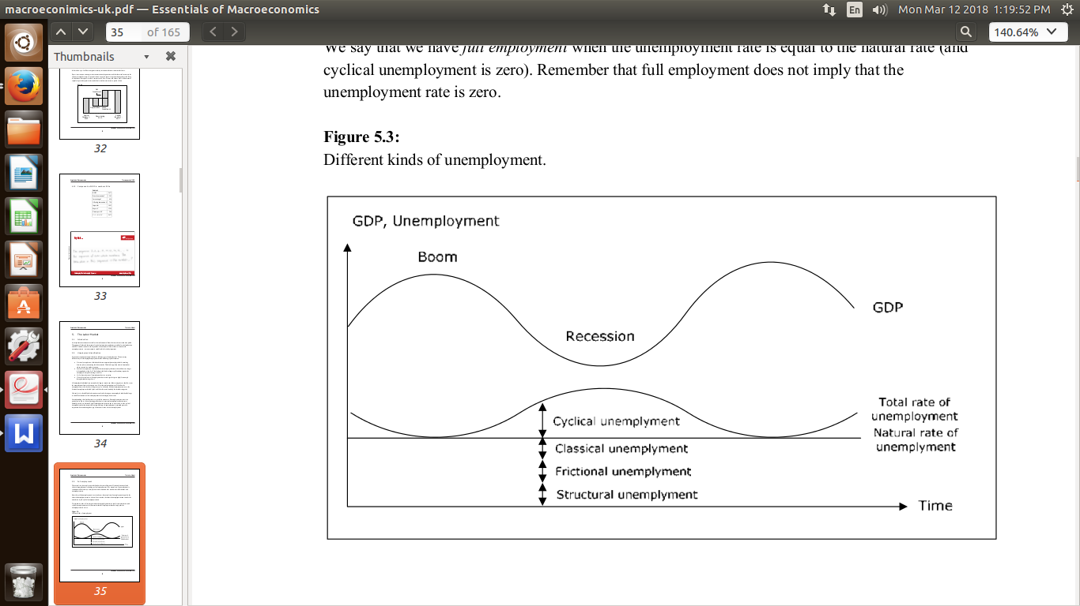

**5.4. Wages**

**5.4.1. Nominal wages**

Nominal wages refer to the straightforward amount of money earned per unit of time, typically in a country’s currency. This is what we commonly refer to as wages. In macroeconomics, when we discuss wages, we mean gross wages — the income earned before income taxes and other employment-related deductions. For instance, if a worker earns $20 per hour, their nominal wage is $20. These wages are considered a flow, meaning they are measured in currency units per hour worked. The nominal wage is straightforward and easy to measure, but it doesn’t account for the purchasing power of the money earned, which is where real wages come into play.

**5.4.2. Wages and income**

It is crucial to distinguish between wages and income. Wages refer specifically to the compensation received for work per unit of time. Income is broader and encompasses all earnings, including wages, investment returns, rental income, and other sources of revenue over a period, like a month or a year. Wages contribute to income, but they do not encompass all forms of earning. For instance, someone might have a high hourly wage but work only part-time, yielding a low monthly income. Conversely, an individual could earn a lower hourly wage but work full-time and have substantial income from investments or real estate.

**5.4.3. Nominal wage level**

The wage level refers to the average wages paid across all jobs in an economy or a specific sector. Instead of focusing on individual wages, the wage level provides a summary statistic that helps understand the general compensation trend. When we say wages are increasing, we often mean that the average wage level is rising. This is different from saying every individual’s wage is increasing, which could be true if higher wages are offered in particular industries or occupations, influencing the average.

**5.4.4. Real wage**

Consider the following scenario. You work full time and during January 2008 you make 2000 euro after tax. A particular basket of goods and services costs 100 euro in January, which means that your salary will buy you 20 such baskets.

In February, you receive a 10% wage increase and you make 2200 euro after tax. Does this imply that you can buy 10% more baskets – that is 22 – in February? Well, not necessarily.

The number of baskets that you can buy in February depends on the possible changes in prices as well. If the price of a basket increases by 3% to 103 euro your 2200 will buy you 2200/103 = 21.36 baskets of 7% more than in January. Even though your wage has increased by 10%, you can only increase your consumption of baskets by 7%. We say that the real wage has increased by 7%.

Formally, we define the real wage as the nominal wage divided by a price index (typically CPI). In the example above, your real wage was 20 in January and 21.36 in February if we use the price of the basket as a price index. Remember that the nominal wage will tell you your wage in units of currency, while the real wage will tell you your wage in baskets of goods and services and this is more important to us.

Therefore, we care about increases in real wages, not in nominal wages. If you found out that Ken, who works in another country, got a 50% increase in his wage each year, you may initially be quite happy for Ken. If you then found out that inflation in the country where Ken works is 70%, you should actually feel sorry for him. His real wage is 1.5/1.7 = 88% of his real wage the year before – a real wage cut by 12%.

**6. Money and banks**

In economics, the term money is not as straightforward as it may seem. Money refers to any commodity or token that is widely accepted as a means of payment for goods and services. This can include currency (notes and coins) as well as bank deposits. The total value of money circulating in an economy at a specific point in time is known as the money supply, a key macroeconomic variable. The importance of the money supply lies in its role as a measure of the amount available for immediate consumption. It influences economic activities by affecting spending, investment, and prices.

**Money Types:**

1. **Currency and Coins:** These are the physical forms of money that are used for everyday transactions. They represent a direct and tangible form of exchange.
2. **Bank Deposits:** This includes savings and checking accounts in commercial banks. They represent money held electronically and can be accessed for transactions. For instance, you might transfer money from your bank account to pay utility bills online.
3. **Money vs. Wealth:** Money and wealth are different concepts. Wealth refers to a person’s or a country’s stock of assets, like real estate or stocks. You can be wealthy without having cash in hand; for instance, owning a home or having a portfolio of investments. Money, on the other hand, is more immediate—it's liquid and can be easily used for transactions.
4. **Money vs. Income:** Income is a flow of money over time, typically measured monthly or annually (like wages or rents). Money is a stock at a specific point in time—how much cash or deposits you have at any moment. It’s possible to have high income but no money (if income is tied up in investments or debt), or to have money but no income (if all your assets are liquid and immediately available).

**6.1. Economic Functions of Money**

1. **Medium of Exchange:** Money simplifies transactions. Without it, we would live in a barter economy where we would have to exchange goods directly (like fish for bread). Money acts as an intermediary that allows us to sell goods for money and then use that money to buy other goods or services.
2. **Unit of Account:** Money provides a standard measure of value, allowing for easy comparison of prices. It simplifies decision-making and facilitates trade.
3. **Store of Value:** Money retains its value over time, which is essential for saving and spending in the future. Unlike perishable goods like food, money can be stored, saved, and spent at a later date. This function allows individuals to plan for future consumption or investment.

**6.2. Central banks**

A central bank is a public authority responsible for monetary policy in a country or a group of countries. Key central banks include the European Central Bank (for the European Monetary Union) and the Federal Reserve in the United States. Central banks hold a monopoly on issuing the national currency and play a crucial role in maintaining monetary stability—whether it's controlling inflation, managing exchange rates, or overseeing financial institutions.

**Primary Responsibilities:**

1. **Monetary Policy:** Central banks control the money supply and interest rates. They can directly influence the overnight interest rate (the rate at which banks lend to each other overnight) and indirectly affect longer-term rates through tools like open market operations. For instance, if the Federal Reserve raises the federal funds rate, this tends to increase borrowing costs throughout the economy.
2. **Regulating Financial Markets:** Central banks regulate and supervise commercial banks and financial institutions to ensure stability and prevent financial crises. This includes setting capital requirements, ensuring liquidity, and monitoring financial risk.
3. **Foreign Exchange Reserves:** Central banks manage the country’s foreign exchange reserves (e.g., gold, foreign currencies) to stabilize the national currency and ensure economic security.
4. **“Bankers’ Bank”:** The central bank also acts as a lender of last resort. Commercial banks can borrow money from the central bank if they face liquidity problems. Every commercial bank in a country has an account at the central bank, which facilitates transactions among banks and ensures the smooth operation of the payment system.

**6.3. Commercial banks**

The fact that currency inside commercial banks is not money may strike you as odd, but it is an important principle. The 100 dollar bill in the ATM will become money only at the instant you withdraw it. The reason is this. We want the money supply to measure how much is available for immediate consumption. But currency inside a bank cannot be used for consumption and this is why it is not counted in the money supply. Cash in the bank is not money, but the binary bits in the bank’s computer system representing the balance in your checking account are!

Commercial banks obviously cannot influence the amount of currency in the economy or the monetary base, since they are not allowed to print money. They can, however, influence the money supply through the second component of the money supply - the deposits. A bank will increase the money supply simply by lending money to a customer. In the same way, when a loan is repaid or amortized, the money supply decreases.

**7. Interest rate**

When you borrow money, you typically incur a cost for using someone else's funds. This cost is known as **interest**, and it is usually expressed as a percentage of the principal amount borrowed, calculated over a specific period of time—commonly per year. For instance, if you borrow **$10,000** at an **annual interest rate of 10%**, you would owe **$1,000** annually in interest. This means that each year, you must pay **$1,000** as a fee for the privilege of borrowing **$10,000**.

Interest rates can be **fixed** or **floating**:

**Fixed Interest Rate**: This means that the interest rate remains constant throughout the life of the loan. No matter how market conditions change, the interest rate you pay remains the same. For example, if you take out a loan with a fixed rate of **5%**, that rate will not change during the term of the loan, regardless of fluctuations in market interest rates.

**Floating Interest Rate**: Also known as a variable interest rate, it adjusts periodically based on prevailing market conditions. This means that the interest rate you pay can change over time. For instance, if your loan is pegged to an index such as the **Prime Rate** or **LIBOR (London Interbank Offered Rate)**, the interest rate you pay can fluctuate as these indices change. This can result in lower rates when market rates are low but could also mean higher costs if market rates rise.

**7.1 The yield curve**

The yield curve is a graph that shows the interest rates of bonds (or other debt securities) with different maturities but similar credit quality at a specific point in time. Typically, the yield curve is upward sloping, meaning that longer-term interest rates are higher than shorter-term ones. This upward slope reflects the risk and liquidity preferences of investors: longer maturities carry more risk because they expose investors to more uncertainty, such as changes in inflation, economic conditions, and interest rates over time. To compensate for this risk, lenders require a higher return for extending the loan over a longer period.

For example, if we look at the yield curve of U.S. Treasury securities at a certain point in time:

* A 1-year Treasury bond might yield 2%.
* A 5-year Treasury bond might yield 3%.
* A 10-year Treasury bond might yield 4%.

This upward slope indicates that investors expect a rising trend in interest rates in the future, reflecting their concern about economic growth and inflation. This is also why many borrowers prefer shorter maturities when borrowing; it reduces exposure to changing interest rates.

**7.2. Overnight interest rates**

Overnight interest rates refer to the cost of borrowing or lending money for just one night. These rates are critical because they influence the short-term liquidity in the banking system. At the end of each business day, banks clear their interbank transactions and reconcile their reserve requirements with the central bank. During this process, banks may borrow from each other or from the central bank to meet their reserve needs, which sets the overnight interest rate.

For instance, consider the daily operations of a central bank like the Federal Reserve in the United States:

* At the end of the banking day, if a bank has a surplus of reserves, it can lend overnight to banks that are short of reserves.
* The interest rate on these overnight loans will reflect supply and demand in this market. If demand for short-term funds is high, the overnight rate will rise; if supply exceeds demand, the rate will fall.

The overnight rate is critical because it serves as a benchmark for other short-term interest rates and influences broader monetary conditions in the economy.

**7.3. Monetary policy**

**Monetary policy** refers to the actions taken by a central bank to control the money supply and interest rates to achieve macroeconomic objectives like controlling inflation, consumption, growth, and liquidity. The central bank uses various tools to implement monetary policy:

1. **Overnight Interest Rates**: The central bank can directly influence short-term interest rates through open market operations—buying or selling government securities in the open market. By setting the target for the overnight rate, the central bank influences other short-term rates throughout the economy. A lower target rate typically stimulates economic activity by encouraging borrowing and investment, while a higher rate slows it down by increasing borrowing costs.  
   For example, if the Federal Reserve in the United States lowers the target for the federal funds rate (the overnight rate) from 2% to 1%, it generally makes borrowing cheaper, encouraging businesses to take loans and consumers to spend more, which can boost economic growth. Conversely, if it raises the rate to 3%, borrowing becomes more expensive, cooling economic activity.
2. **The Monetary Base**: This includes currency in circulation plus reserves held by banks at the central bank. The central bank controls the monetary base through mechanisms like open market operations and setting reserve requirements. By increasing the money supply through these operations, the central bank can stimulate economic activity. For instance, during a recession, a central bank might buy government bonds to inject liquidity into the banking system, increasing reserves and lowering interest rates to spur borrowing and spending.
3. **Interest Rates with Longer Maturity**: Although the central bank has direct control over overnight rates, its influence extends to longer-term interest rates as well. For instance, when the central bank lowers the target rate for overnight loans, the expectation is that this action will also lower longer-term interest rates over time, making borrowing more attractive for business investments and consumer loans. However, this effect is less direct and depends on market expectations and responses.
4. **Inflation**: Controlling inflation is a primary goal of monetary policy. The central bank can use interest rates to influence aggregate demand. For example, if the central bank raises the target interest rate to curb inflation, borrowing costs increase, consumer spending and investment decrease, which generally reduces inflationary pressures.

**7.4 Nominal and real interest rates**

To distinguish the real interest rate from the "normal" interest rate, the latter is called the nominal interest rate. The nominal interest rate shows the growth of your money while the real rate shows the growth of what your money can buy.

**8. Macroeconomic models**

**8.1. Introduction**

Using these models, we can analyze various economic scenarios, such as the impact of government increasing consumption, the effects of the central bank raising the target interest rate, and the success of domestically produced goods in foreign markets. These models help us understand key observations about the economy, such as cyclical fluctuations in growth, the correlation between unemployment and inflation, and the relationship between interest rates and foreign exchange rates.

However, macroeconomics is not an exact science like physics. There is no definitive way to precisely determine how macroeconomic variables are interconnected. Instead, we rely on a variety of models that attempt to explain different observations and relationships between macroeconomic variables. Unfortunately, these models can sometimes be inconsistent. For example, one model might predict that lowering the central bank’s target interest rate will reduce unemployment, while another might argue it has no effect. This inconsistency reflects the complexity and variability of real-world economic interactions.

Economic theory is not a matter of finding one universal “truth” but rather understanding that different models can offer different explanations for observed phenomena. No single model can capture all aspects of the economy; each has its limitations and assumptions. When we conclude that “An increase in x will lead to an increase in y,” we should recognize that this is specific to a particular model rather than an absolute truth about the real world.

One prominent model used in many introductory macroeconomics courses worldwide is the so-called neo-classical synthesis. This model blends elements of the classical and Keynesian frameworks, suggesting that Keynesian theories apply in the short term while classical theories hold in the long run. The rest of this book builds upon this neo-classical synthesis, which incorporates various minor variations. This approach allows for a more nuanced understanding of economic dynamics and the interplay between short-term and long-term economic factors.

**8.2. Common assumptions**

All models require a number of assumptions to be able to say anything of interest.

**8.2.1. Unemployment and hours worked are directly related**

In all models, we typically assume a negative relationship between the number of hours worked and unemployment. This means that if the number of hours worked increases, unemployment tends to decrease, and conversely, if hours worked decrease, unemployment tends to rise. This assumption holds under the premise that the workforce remains constant and individuals either work full time or not at all.

However, in reality, this relationship may not always hold true. Factors such as changes in the labor force—like an influx of immigrants—could alter the dynamics. For instance, if the labor force expands more rapidly than employment growth, it might lead to an increase in both the number of hours worked and unemployment. This scenario can complicate the straightforward negative relationship typically assumed in models. Despite this, many models continue to simplify this relationship by not accounting for such nuances.

**8.2.2. The central bank has complete control over money supply**

The central bank holds complete control over the money supply. This is achieved through the money multiplier, which is the factor that amplifies changes in the monetary base into changes in the money supply. The money multiplier is assumed to be constant, meaning it doesn’t fluctuate significantly in response to changes in the monetary base. Since the monetary base itself is entirely under the control of the central bank—through tools like open market operations, reserve requirements, and the discount rate—the central bank can effectively manage the money supply.

This relationship allows the central bank to directly influence the overall supply of money in the economy. By adjusting the monetary base—say, by buying or selling government securities in the open market or changing reserve requirements—central banks can control the money supply. This direct control underscores the central role of the monetary base in determining money supply dynamics, ensuring the central bank has a powerful tool for steering monetary policy.

**8.2.3. Monetary policy = change in money supply**

Monetary policy primarily involves changes in the money supply. However, the central bank possesses additional instruments beyond simply determining the money supply. The most significant among these is the target interest rate for the overnight market. While this book will not delve into altering the target interest rate specifically, it’s important to recognize that there is a negative relationship between the target rate and the money supply. This means that an increase in the target interest rate would effectively reduce the money supply. Therefore, when examining the effects of a rise in the target rate, you can equivalently study the impacts of a decrease in the money supply.

Consider a central bank that decides to raise the target interest rate for the overnight market. In response, banks will likely increase the rates on their loans to consumers and businesses to maintain profitability, reflecting the higher cost of borrowing money. As a result, the money supply contracts because loans become more expensive, deterring borrowing and spending. This contraction in the money supply could be mirrored as an outcome if the central bank chose to directly reduce the supply of money instead. Both scenarios show a negative impact on economic activity—slower growth and potentially higher interest rates—demonstrating how the central bank’s choice of interest rate can indirectly control the money supply.

**8.2.4. There is just one interest rate**

Incorporating different interest rates with varying maturities into exchange rate models might complicate things, but it doesn’t necessarily provide much additional insight. Interest rates with different maturities are closely correlated—they generally move in the same direction. What primarily matters in these models is the direction of the variable rather than its exact value. To keep things simple, we often refer to “the interest rate” as the one-year interest rate on government securities. This choice streamlines the model and focuses on the essential relationship between interest rates and exchange rates without getting bogged down in the nuances of varying maturities.

**8.2.5. Exchange rate**

In all models considering exchange rates, we assume that the exchange rate is flexible. This means that the exchange rate adjusts freely based on market forces—specifically, the ratio of domestic price levels to foreign price levels. When domestic prices increase while foreign prices remain constant, the domestic currency depreciates relative to the foreign currency. For instance, if domestic prices rise by 10% and foreign prices stay stable, the domestic currency will weaken by 10% against the foreign currency. This depreciation allows exports to remain competitive abroad because the higher domestic prices are offset by the depreciation, making them relatively cheaper for foreign buyers. Similarly, it adjusts the cost of imports for domestic consumers to keep them relatively unaffected by the domestic price increase.

Let’s consider a hypothetical scenario involving India and the United States. If India experiences a 20% increase in domestic prices due to inflation, while U.S. prices stay constant, under a flexible exchange rate system, the Indian rupee would depreciate by 20% relative to the U.S. dollar. This depreciation neutralizes the effect of higher domestic prices on Indian exports, allowing Indian goods to remain competitive in international markets. Foreign buyers would still find Indian products attractive because their cost in terms of the depreciated rupee remains unchanged.

On the import side, Indian consumers purchasing goods from abroad would see a similar adjustment. Even though domestic prices have increased, the weaker rupee means the effective price of foreign goods in Indian rupees would remain relatively stable. This mechanism shields international trade balances from inflation and ensures the stability of cross-border transactions.

**8.2.6. Capital Flows**

When domestic interest rates rise above foreign interest rates, it makes investments in the home country more attractive to foreign investors. This is because higher interest rates generally offer better returns on savings and investments, such as bonds or deposits. As a result, capital flows into the domestic economy as foreign investors move their money to take advantage of these higher returns. This inflow of capital increases the supply of money in the domestic market, which can put downward pressure on the domestic interest rate over time, gradually bringing it back down.

However, the relationship between domestic and foreign interest rates is complex and influenced by several factors, including exchange rates, capital controls, and government policies. Advanced economic models that incorporate these factors provide a more realistic picture of how capital flows impact interest rates, but the basic principle remains: higher domestic interest rates initially attract foreign capital.

Imagine India raises its interest rates to combat domestic inflation, while the U.S. Federal Reserve keeps its rates steady. As a result, Indian government bonds and fixed deposits become more attractive to global investors seeking higher returns. Large-scale investment flows into India, requiring investors to exchange U.S. dollars for Indian rupees. This increased demand for rupees causes the rupee to appreciate, making imports cheaper but potentially reducing export competitiveness. Over time, the additional liquidity from these capital inflows increases the supply of money in the financial system, causing domestic interest rates to ease back down toward equilibrium.

For years, China maintained strict controls over capital inflows and outflows. Let’s assume during this period that China increased its domestic interest rate while keeping its currency pegged to the U.S. dollar. Despite the higher interest rate, foreign capital could not flow in freely due to restrictions. As a result, the domestic interest rate remained elevated without being impacted by external capital. This protected China from excessive currency appreciation but also limited the immediate benefits of foreign investment, such as increased liquidity and funding for domestic projects.

By examining these cases, we can see how countries with open capital markets experience more dynamic interactions between domestic and foreign interest rates, while economies with restricted flows can insulate themselves from such effects, albeit with significant trade-offs.

**8.3.1. Supply and demand** In microeconomics, we emphasize the distinction between three fundamental concepts: demand, supply, and the observed quantity. Demand and supply are theoretical constructs—they represent the *intentions* or *desires* of households and firms under various conditions. Demand indicates how much consumers want to buy at given prices, while supply reflects how much producers intend to sell. Both are functions, meaning their values depend on other variables like price, income, or preferences. For example, if the price of smartphones decreases, the demand for them might rise, illustrating how demand depends on price. However, the observed quantity is different—it is the actual outcome in the market, determined by the interaction of demand and supply. For instance, if a shortage occurs, the observed quantity of smartphones sold will be lower than the demand. Unlike demand and supply, the observed quantity is a measurable variable, providing insights into market behavior but not the underlying intentions driving it. These relationships are often visualized in charts, where demand and supply curves highlight how quantities respond to changes in key factors.

In macroeconomics, this distinction also applies but on a much larger scale, involving aggregate variables that reflect the economy as a whole. Until now, variables like L (the total hours worked) have typically been treated as observed quantities—measurable outcomes that summarize market interactions. However, just as in microeconomics, we need to differentiate between the demand and supply sides of these variables to understand the forces shaping their observed values. For example, in the labor market, ‘L’ represents the actual hours worked, but LS (labor supply) captures how many hours workers are willing to work at various wage levels, while LD (labor demand) reflects how many hours firms are willing to hire. This distinction applies across key macroeconomic variables like output (Y), capital (K), money supply (M), consumption (C), investment (I), government spending (G), exports (X), and imports (Im). For instance, if YD > YS , it might indicate inflationary pressures, while LD < LS could signal unemployment.

Understanding these dynamics helps clarify how markets function at both individual and aggregate levels. For example, consider a spike in energy prices. If firms cannot adjust production quickly, YS may remain unchanged in the short term, leading to a mismatch with YD. Such situations, reflected in the labor and capital markets, emphasize the importance of distinguishing between the theoretical supply and demand forces and the observed outcomes we measure.

**9. Numericals on GDP**

1. Calculating GDP using the Expenditure Approach: Suppose a country has the following data:

Total Consumption (C) = $300 billion

Total Investment (I) = $150 billion

Government Spending (G) = $200 billion

Exports (X) = $50 billion

Imports (Im) = $30 billion

Using the expenditure approach:

GDP=C+I+G+(X−Im)

GDP=300+150+200+(50−30)

GDP=300+150+200+20=670 billion

1. Calculating GDP using the Value Added Approach: Consider three firms in the economy:

Firm A: Value Added = $50 billion

Firm B: Value Added = $70 billion

Firm C: Value Added = $30 billion

Total Value Added:

GDP=Value Added at Firm A+Value Added at Firm B+Value Added at Firm C

GDP=50+70+30=150 billion

1. Calculating GDP using the Components Approach: Given the data:

Consumption (C) = $300 billion

Investment (I) = $150 billion

Government Spending (G) = $200 billion

Net Exports (NX) = $20 billion (exports - imports)

Using the components approach:

GDP=C+I+G+NX

GDP=300+150+200+20

GDP=670 billion

1. Calculating GDP using the Income Approach: Given data:

Wages and Salaries = $400 billion

Interest = $50 billion

Rent = $30 billion

Profits = $120 billion

Using the income approach:

GDP=Wages+Interest+Rent+Profits

GDP=400+50+30+120

GDP=600 billion

These numerical examples illustrate how GDP can be calculated using different approaches—expenditure, value added, components, and income. Each method provides a distinct perspective on the economic output of a country.

**10. Overview of ESG (Environmental, Social, and Governance)**

ESG refers to the three key factors used to measure the sustainability and societal impact of an investment in a company or business. It stands for Environmental, Social, and Governance:

1. Environmental (E): This aspect focuses on a company's impact on the environment and includes factors such as carbon emissions, waste management, resource use, and environmental policies. Companies that perform well in this category are those that aim to minimize their carbon footprint, use resources efficiently, and implement sustainable practices. For example, a company may invest in renewable energy, implement waste recycling programs, and reduce pollution to achieve environmental sustainability.
2. Social (S): This component evaluates how a company manages relationships with its employees, suppliers, customers, and the communities in which it operates. It includes factors like labor practices, health and safety standards, community development, diversity and inclusion, and human rights. A company that excels in social aspects often promotes a positive workplace culture, ensures fair labor practices, and contributes to the local community. For example, a company might provide fair wages, invest in employee training, and engage in philanthropy.
3. Governance (G): This factor assesses the structure and quality of a company’s leadership and governance practices. It includes aspects such as board diversity, executive compensation, shareholder rights, transparency, and anti-corruption measures. Good governance practices help ensure that a company is accountable to its stakeholders, operates with integrity, and makes decisions that align with long-term value creation. For example, a company with strong governance might have an independent board of directors, clear executive pay policies, and robust internal controls.